Institute of Computer Technology

B. Tech Computer Science and Engineering

Sub: Database Management System (2CSE301)

Practical 4: Create tables with various Data Constraints and verify by inserting values in it.

Scenario : Mohan as an engineer know what are the issues when an entry gets wrongly inserted. Thus to avoid such issues Mohan suggested to have constraints so that whenever by mistake also if someone tries to enter data can first get checked and than inserted.

# A) Table Name: Client_master

Description: Used to store information about clients.

|  |  |  |  |
| --- | --- | --- | --- |
| **Column Name** | **Data Type** | **Size** | **Attributes** |
| Product_no | Varchar | 6 | Primary key/ first letter must start with ‘P’ |

|  |  |  |  |
| --- | --- | --- | --- |
| **Column Name** | **Data Type** | **Size** | **Attributes** |
| Client_no | Varchar | 6 | Primary key/ first letter must start with ‘C’ |
| Name | Varchar | 15 | Not Null |
| City | Varchar | 15 |  |
| Pincode | Numeric | 8 |  |
| State | Varchar | 15 |  |
| Bal_due | Numeric | 10,2 |  |

|  |  |  |  |  |  |
| --- | --- | --- | --- | --- | --- |
| **Client_no** | **Name** | **City** | **Pincode** | **State** | **Bal_due** |
| C001 | Ivan | Bombay | 400054 | Maharashtra | 15000 |
| C002 | Vandana | Madras | 780001 | Tamil Nadu | 0 |
| C003 | Pramada | Bombay | 400057 | Maharashtra | 5000 |
| C004 | Basu | Bombay | 400056 | Maharashtra | 0 |
| C005 | Ravi | Delhi | 100001 | Gujarat | 2000 |
| C006 | Rukmani | Bombay | 400050 | Maharashtra | 0 |

Table Code:

create table Client_master (

client_no varchar(6) primary key check (client_no like 'c%'),

name varchar(15) not null,

city varchar(15),

pincode numeric(8),

state varchar(15),

bal_due numeric(10, 2)

);

insert into Client_master values ('C001','Ivan','Bombay',400054,'Maharashtra',15000 );

insert into Client_master values ('C002','Vandana','Madras',780001,'Tamil Nadu', 0 );

insert into Client_master values ('C003','Pramada','Bombay',400057,'Maharashtra',5000 );

insert into Client_master values ('C004','Basu','Bombay',400056,'Maharashtra',0 );

insert into Client_master values ('C005','Ravi','Delhi',100001,'Gujarat',2000 );

insert into Client_master values ('C006','Rukmani','Bombay',400050,'Maharashtra',0 );

select *from Client_master;

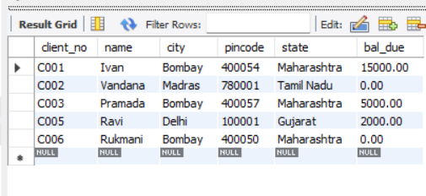

# B) Table Name: Product_master

Description: Used to store information about products.

|  |  |  |  |  |  |  |  |  |  |
| --- | --- | --- | --- | --- | --- | --- | --- | --- | --- |
| Description | | Varchar | | 15 | Not Null | | |  |  |
| P_percent | | Numeric | | 4,2 | Not Null | | |
| U_measure | | Varchar | | 10 | Not Null | | |
| Qty_on_hand | | Numeric | | 8 | Not Null | | |
| Reorder_lvl | | Numeric | | 8 | Not Null | | |
| Sell_price | | Numeric | | 8,2 | Not Null, cannot be 0 | | |
| Cost_price | | Numeric | | 8,2 | Not Null, cannot be 0 | | |
| Product_ No | Description | | P_  Percent | U_  Measure | | Qty_on_ hand | Reorder_ Lvl | sell_ price | Cost_ Price |
| P001 | Floppies | | 5 | Piece | | 100 | 20 | 525 | 500 |
| P002 | Monitor | | 6 | Piece | | 10 | 3 | 12000 | 11280 |
| P003 | Mouse | | 5 | Piece | | 20 | 5 | 1050 | 1000 |
| P004 | Floppies | | 5 | Piece | | 100 | 20 | 525 | 500 |
| P005 | Keyboards | | 2 | Piece | | 10 | 3 | 3150 | 3050 |
| P006 | Cd Drive | | 2.5 | Piece | | 10 | 3 | 5250 | 5100 |
| P007 | 1.44 Drive | | 4 | Piece | | 10 | 3 | 8400 | 8000 |
|  |  | |  |  | |  |  |  |  |

create table Product_master(

Product_no varchar(6),

Description varchar(15) not null,

P_percent numeric(4,2) not null,

U_measure varchar(10) not null,

Qty_on_hand numeric(8) not null,

Reorder_lvl numeric(8) not null,

Sell_price numeric(8,2) not null,

Cost_price numeric(8,2) not null,

primary key(Product_no),

check (Product_no like 'P%'),

check (Sell_price > 0),

check (Cost_price > 0)

);

insert into product_master values('P001', 'Floppies', 5, 'Piece', 100, 20, 525, 500);

insert into product_master values('P002', 'Monitor', 6, 'Piece', 10, 3, 12000, 11280);

insert into product_master values('P003', 'Mouse', 5, 'Piece', 20, 5, 1050, 1000);

insert into product_master values('P004', 'Floppies', 5, 'Piece', 100, 20, 525, 500);

insert into product_master values('P005', 'Keyboards', 2, 'Piece', 10, 3, 3150, 3050);

insert into product_master values('P006', 'Cd Drive', '2.5', 'Piece', 10, 3 ,5250, 5100);

insert into product_master values('P007', '1.44 Drive', 4, 'Piece', 10, 3, 8400, 8000);

select * from product_master;

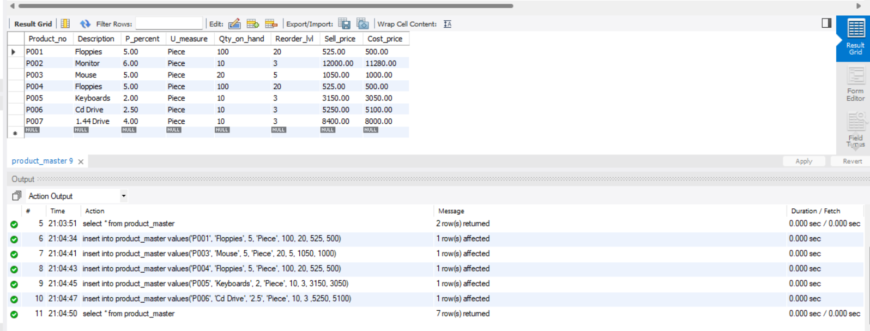

# C) Table Name: Salesman_master

Description: Used to store information about salesman working in the company.

|  |  |  |  |
| --- | --- | --- | --- |
| **Column Name** | **Data Type** | **Size** | **Attributes** |
| Order_no | Varchar | 6 | Primary key/ first letter must start with ‘O’ |

|  |  |  |  |
| --- | --- | --- | --- |
| **Column Name** | **Data Type** | **Size** | **Attributes** |
| S_no | Varchar | 6 | Primary key/ first letter must start with ‘S’ |
| S_name | Varchar | 15 | Not Null |
| City | Varchar | 10 |  |
| Pincode | Numeric | 8 |  |
| State | Varchar | 12 |  |
| Sal_amt | Numeric | 8,2 | Not Null, cannot be 0 |
| Tgt_to_get | Numeric | 6,2 | Not Null, cannot be 0 |
| Ytd_sales | Numeric | 6,2 | Not Null |
| Remarks | Varchar | 20 |  |

|  |  |  |  |  |  |  |  |  |
| --- | --- | --- | --- | --- | --- | --- | --- | --- |
| S_no | S_name | City | Pincode | State | Sal_ Amt | Tgt_ to get | Ytd_ Sales | remarks |
| S001 | Kiran | Bombay | 400002 | Maharashtar | 3000 | 100 | 50 | Excellent |
| S002 | Manish | Bombay | 400001 | Maharashta | 3000 | 200 | 100 | Good |
| S003 | Ravi | Bombay | 400032 | Maharashta | 3000 | 200 | 100 | Average |
| S004 | Ashish | Bombay | 400044 | Maharashta | 3500 | 200 | 150 | Good |

create table salesman_master (

s_no varchar(6),

s_name varchar(15) not null,

city varchar(10),

pincode numeric(8),

state varchar(12),

sal_amt numeric(8,2) not null,

tgt_to_get numeric(6,2) not null,

ytd_sales numeric(6,2) not null,

remarks varchar(20),

primary key (s_no),

check (s_no like 's%'),

check (sal_amt > 0),

check (tgt_to_get > 0)

);

insert into salesman_master values('S001', 'Kiran', 'Bombay', 400002, 'Maharashtar', 3000, 100, 50, 'Excellent');

insert into salesman_master values('S002', 'Manish', 'Bombay', 400001, 'Maharashta', 3000, 200, 100, 'Good');

insert into salesman_master values('S003', 'Ravi', 'Bombay', 400032, 'Maharashta', 3000, 200, 100, 'Average');

insert into salesman_master values('S004', 'Ashish', 'Bombay', 400044, 'Maharashta', 3500, 200, 150, 'Good');

select * from salesman_master;

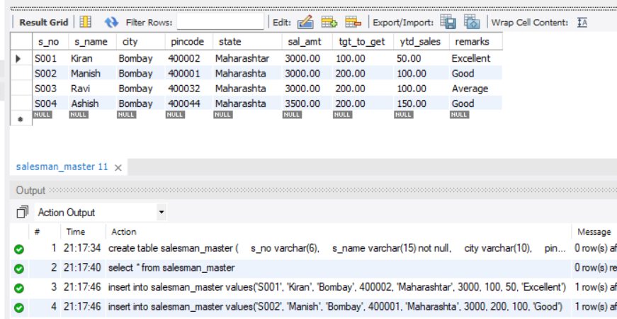

# D) Table Name: Sales_order

Description: Used to store client’s orders.

|  |  |  |  |
| --- | --- | --- | --- |
| Order_date | Date |  |  |
| Client_no | Varchar | 6 | Foreign key references client_no of client_master table. |
| S_no | Varchar | 6 | Foreign key references s_no of salesman_master table. |
| Dely_type | Char | 1 | Delivery: part(P) / full (F) Default ‘F’ |
| Billed_yn | Char | 1 |  |
| Dely_date | Date |  | Cannot be less than order_date |
| Order_status | Varchar | 10 | Values(‘inprocess’,’fullfiled’,’backorder’,’cancelled’) |

|  |  |  |  |  |  |  |  |
| --- | --- | --- | --- | --- | --- | --- | --- |
| Order_no | Order_date | Client_no | S_no | Dely_ type | Billed_yn | Dely_date | Order_status |
| O1901 | 12-Jan-06 | C001 | S001 | F | N | 20-Jan-06 | In Process |
| O1902 | 25-Jan-06 | C002 | S002 | P | N | 27-Jan-06 | Cancelled |
| O4665 | 18-feb-06 | C003 | S003 | F | Y | 20-Feb-06 | Fullfilled |
| O1903 | 03-Apr-06 | C001 | S001 | F | Y | 07-Apr-06 | Fullfield |
| O4666 | 20-May-06 | C004 | S002 | P | N | 22-May-06 | Cancelled |
| O1908 | 24-May-06 | C005 | S003 | F | N | 26-May-06 | In Process |

create table sales_order (

order_no varchar(6),

order_date date,

client_no varchar(6),

s_no varchar(6),

dely_type char(1) default 'F',

billed_yn char(1),

dely_date date,

order_status varchar(10),

primary key(order_no),

foreign key(client_no) references client_master(client_no),

foreign key(s_no) references salesman_master(s_no),

check (order_no like 'O%'),

check (dely_type like 'F' or dely_type like 'P'),

check (date(dely_date) > date(order_date)),

check (order_status = 'inprocess' or order_status = 'fullfiled' or order_status = 'backorder' or order_status = 'cancelled')

);

insert into sales_order values('O1901', '2006-01-12', 'C001', 'S001', 'F', 'N', '2006-01-20', 'inprocess');

insert into sales_order values('O1902', '2006-01-25', 'C002', 'S002', 'P', 'N', '2006-01-27', 'cancelled');

insert into sales_order values('O4665', '2006-02-18', 'C003', 'S003', 'F', 'Y', '2006-02-20', 'fullfiled');

insert into sales_order values('O1903', '2006-04-03', 'C001', 'S001', 'F', 'Y', '2006-04-07', 'fullfiled');

insert into sales_order values('O4666', '2006-05-20', 'C004', 'S002', 'P', 'N', '2006-05-22', 'cancelled');

insert into sales_order values('O1908', '2006-05-24', 'C005', 'S003', 'F', 'N', '2006-05-26', 'inprocess');

select * from sales_order;

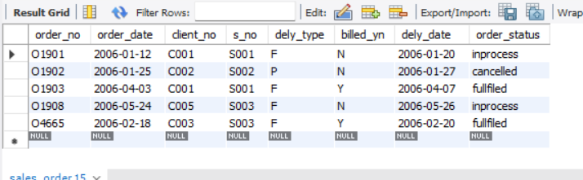

# E) Table Name: Sales_order_details

Description: Used to store client’s orders with details of each product ordered.

|  |  |  |  |
| --- | --- | --- | --- |
| **Column Name** | **Data Type** | **Size** | **Attributes** |
| Order_no | Varchar | 6 | Primary Key/ Foreign Key references order_no of the sales_order table. |
| Product_no | Varchar | 6 | Primary Key/ Foreign Key references product_no of the Product_master table. |
| Qty_ordered | Numeric | 8 |  |
| Qty_disp | Numeric | 8 |  |
| Product_rate | Numeric | 10,2 |  |

|  |  |  |  |  |
| --- | --- | --- | --- | --- |
| **Order_no** | **Product_no** | **Qty_ordered** | **Qty_disp** | **Product_rate** |
| O1901 | P001 | 4 | 4 | 525 |
| O1901 | P002 | 2 | 1 | 8400 |
| O1901 | P003 | 2 | 1 | 5250 |
| O1902 | P001 | 10 | 0 | 525 |
| O4665 | P002 | 3 | 3 | 3150 |
| O4665 | P004 | 3 | 1 | 5250 |
| O4665 | P005 | 10 | 10 | 525 |
| O4665 | P003 | 4 | 4 | 1050 |
| O1903 | P006 | 2 | 2 | 1050 |
| O1903 | P004 | 1 | 1 | 12000 |
| O1908 | P005 | 1 | 0 | 8400 |
| O1908 | P007 | 10 | 0 | 1050 |

**create table sales_order_details (**

**order_no varchar(6),**

**product_no varchar(6),**

**qty_ordered numeric(8),**

**qty_disp numeric(8),**

**product_rate numeric(10, 2),**

**primary key (order_no, product_no),**

**foreign key (order_no) references sales_order(order_no),**

**foreign key (product_no) references product_master(product_no)**

**);**

**insert into sales_order_details values('O1901', 'P001', '4', '4', '525');**

**insert into sales_order_details values('O1901', 'P002', '2', '1', '8400');**

**insert into sales_order_details values('O1901', 'P003', '2', '1', '5250');**

**insert into sales_order_details values('O1902', 'P001', '10', '0', '525');**

**insert into sales_order_details values('O4665', 'P002', '3', '3', '3150');**

**insert into sales_order_details values('O4665', 'P004', '3', '1', '5250');**

**insert into sales_order_details values('O4665', 'P005', '10', '10', '525');**

**insert into sales_order_details values('O4665', 'P003', '4', '4', '1050');**

**insert into sales_order_details values('O1903', 'P006', '2', '2', '1050');**

**insert into sales_order_details values('O1903', 'P004', '1', '1', '12000');**

**insert into sales_order_details values('O1908', 'P005', '1', '0', '8400');**

**insert into sales_order_details values('O1908', 'P007', '10', '0', '1050');**

**select * from sales_order_details;**

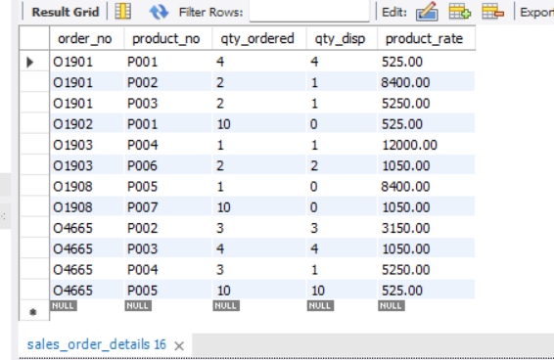

**Exercise:**

Create Above tables with given constraints and insert data in it.